7.16 Percents
same images as 6.21 (shapes)
Problem 1
Rationalnum_100_1
Using the set of shapes in the picture, answer questions 2 through 4 in the worksheet provided:
(1)What percent of the shapes are squares?
(2) What percent of the shapes are purple?
(3) What percent of the shapes are not blue?
(4) What percent of the shapes are red?
Number of target items/Total number of items/unreduced ratio/ratio out of 100/decimal/reduced fraction

The unreduced ratio is Number of Target Items/Total Number of Items
Problem 2
Rationalnum_100_2
(1) What percent of the shapes are purple or yellow?
(2) What percent of the shapes are purple?
(3) What percent of the shapes are gray?
(4) What percent of the shapes are green?
*same exact symbol as 100_grid

Problem 3
Rationalnum_10_1
same as purple dot
(1) What percent of the shapes are red or blue?
(2) What percent of the shapes are not purple?
(3) What percent of the shapes are squares?
(4) What percent of the shapes are blue squares?
*WILL LET YOU ENTER INCORRECT DECIMAL PLACE .1= .103, allows the 03 or 0003

Problem 4

Graph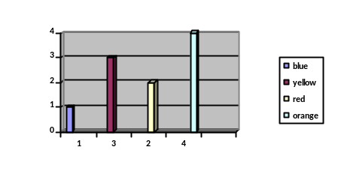
- What percent of the shapes are not blue?
- What percent of the shapes are not orange?
- What percent of the shapes are yellow?
- What percent of the shapes are red?

Problem 5

20 images: 10 square, 10 circles
2 red circles, 2 red squares
1 gray circle, 1 gray square
4 yellow circles, 4 yellow squares
3 blue circles, 2 blue squares
1 green square

- What percent of the shapes are green?
- What percent of the shapes are yellow?
- What percent of the shapes are blue?
- What percent of the shapes are not blue?

Problem 6

25 images: 15 squares, 10 circles
5 blue squares, 5 blue circles
5 green squares, 5 green circles
5 yellow squares

- What percent of the shapes are circles?
- What percent of the shapes are yellow?
- What percent of the shapes are green or blue?
- What percent of the shapes are squares?

Problem 7

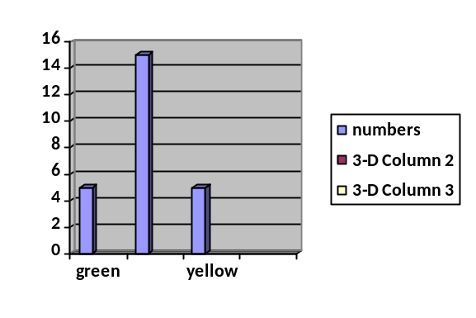
Graph
- What percent of the shapes are green?
- What percent of the shapes are blue?
- What percent of the shapes are not yellow?
- What percent of the shapes are green or yellow?

Problem 8

40 shapes: 10 squares, 30 circles
24 green circles, 8 green squares
3 blue circles, 2 blue squares
3 black circles
- What percent of the shapes are green?
- What percent of the shapes are blue?
- What percent of the shapes are circles?
- What percent of the shapes are black?

Problem 9

Graph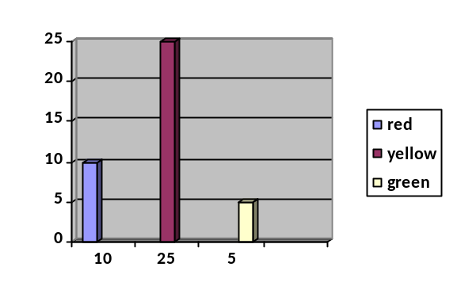

- What percent of the shapes are yellow or green?
- What percent of the shapes are yellow?
- What percent of the shapes are green?
- What percent of the shapes are not yellow?

Problem 10

50 shapes: 25 circles, 25 squares
5 yellow squares
15 blue squares
5 red squares, 15 red circles
10 purple circles

- What percent of the shapes are yellow?
- What percent of the shapes are circles?
- What percent of the shapes are not yellow?
- What percent of the shapes are blue or red?

Problem 11

50 shapes: 41 squares, 9 circles
5 green squares
3 blue squares, 2 blue circles
7 red circles, 28 red squares
5 yellow squares

- What percent of the shapes are blue circles?
- What percent of the shapes are red?
- What percent of the shapes are green?
- What percent of the shapes are red circles?

Problem 12

5 shapes
1 red circle
2 blue circles, 2 blue squares

- What percent of the shapes are circles?
- What percent of the shapes are circles or squares?
- What percent of the shapes are red?
- What percent of the shapes are blue?

Problem 13

80 shapes: 60 squares, 20 circles
54 purple squares
6 green squares, 2 green circles
8 yellow circles
2 black circles
8 blue circles

- What percent of the shapes are green circles?
- What percent of the shapes are squares?
- What percent of the shapes are green circles or black circles?
- What percent of the shapes are purple?

Problem 14

80 shapes: 64 squares, 16 circles
32 black squares, 12 black circles
4 green circles, 10 green squares
18 yellow squares
4 blue squares

- What percent of the shapes are not yellow?
- What percent of the shapes are yellow?
- What percent of the shapes are black?
- What percent of the shapes are not circles?

